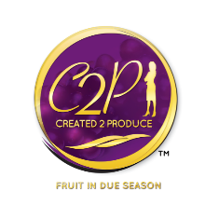Cassandra Scott Ministries
Getting to know you form….

Name
Phone
Email
Address
Church Home
Profession
Gifts & Calling
First time doing in-home prayer
Have you been on prayerline? If so how long?
Have you been filled with the Spirit (speaking in tongues)
Are there any areas that you would like more information about?
How can we be more helpful to you?

www.created2produce.org
info@created2produce.com

